|  |
| --- |
| IFMR RURAL FINANCE |
| Field Appraisal Review |
|  |
| **IFMR Rural Finance** |
| **10/11/2016** |

|  |
| --- |
|  |

Contents

Process Diagram 3

1. Stage definition 4

2. Stage-role access 4

3. Field Appraisal Queue 4

3.1 UI specification 4

3.2 Screenshot 5

3.3 Functional requirements 5

3.4 Upload 6

3.5 Download 6

3.6 Reports 6

4. Capturing Field Appraisal data 7

4.1 UI requirements 7

4.2 Screenshots 30

4.3 Functional requirements 57

4.4 Uploads 57

4.5 Downloads 57

4.6 Reports 57

5. Risk Score 2 57

5.1 UI specification 57

5.2 Screenshot 57

5.3 Functional requirements 57

5.4 Upload 57

5.5 Download 57

5.6 Reports 57

# Process

## 1.1 PROCESS FLOWCHART

E:\sarthak.shah\Desktop\Field Appraisal Review 3.0.png

## 1.2 PROCESS STEPS

1. Central Risk Officer logs in and is able to view all profiles that completed Application Stage.
2. CRO can search profiles based on the following criteria
   * + Applicant Name
     + Business Name
     + URN Number
     + Area
     + City /Village/Town
3. All search parameters except pincode will have a sort/arrange facility
4. CRO will click on the desired profile to select the customer. Data of that customer will be auto-populated and all the fields will be displayed.
5. CRO can view summary of all details captured and also all details.
6. CRO is supposed to take decision on whether to accept/reject/send back/hold.
7. If accept then enter details about reference check. On Submit system will calculate risk score.
8. If Reject then system will reject the application after capturing rejection remarks.
9. If Hold the applicant will be added back to the Field Appraisal Review Queue.
10. If Send back then he is supposed to select screening/application/field appraisal stage where application has to be sent back.
11. Stop.

# Stage definition

|  |  |
| --- | --- |
| **Stage** | **Description** |
| Field Appraisal Review Queue | The Credit Risk Officer selects a profile from the pending for field appraisal review queue (i.e. completed field appraisal) |
| Capture Details | The Credit Risk Officer captures data and submits the same for calculation of risk score 3 |
| Risk Score | The system must calculate the consolidated risk score |

# Stage-role access

|  |  |
| --- | --- |
| **Stage** | **Applicable Role** |
| Field Appraisal Queue | Credit Risk Officer |
| Capture Details | Credit Risk Officer |
| Risk Score 3 | -NA- |

# Field Appraisal Queue

## UI specification

|  |  |  |  |  |
| --- | --- | --- | --- | --- |
| **Field name** | **Section** | **Data Type** | **Attribute** | **Population logic** |
| Applicant Name | Field Appraisal Review Queue | Text | Sort/search | From field appraisal stage |
| Business Name | Field Appraisal Review Queue | Alphanumeric | Sort/search | From field appraisal stage |
| URN No | Field Appraisal Review Queue | Alphanumeric | Sort/search | From field appraisal stage |
| Area | Field Appraisal Review Queue | Text | Sort/search | From field appraisal stage |
| City/Village/ Town | Field Appraisal Review Queue | Text | Sort/search | From field appraisal stage |
| Pincode | Field Appraisal Review Queue | Numeric |  | From field appraisal stage |

## Screenshot

* + 1. Search Page

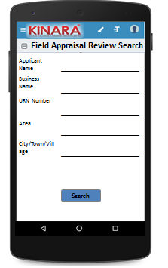

* + 1. Field Appraisal Review Queue

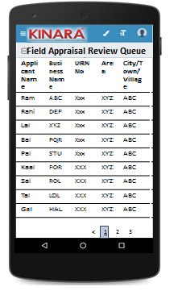

## Functional requirements

**Credit Risk Officer (CRO)** logs in

* The CRO opens the process dash board, and clicks on Field Appraisal Review queue
* If the CRO performs a search without selecting any parameter, then all cases with status ‘Pending for Field Appraisal Review’ to be displayed in a tabular format.
* If the CRO searches with ‘Applicant name’, ‘Business name’ or ‘URN no’, then all matching records that are ‘Pending for Field Appraisal Review’ (including existing customers) to be displayed in a tabular format.
* The CRO can **search and sort** the profiles based on the following parameters: URN no, Applicant Name, Business Name, Area, City/Village/Town.
* The CRO then selects a profile from the field appraisal review queue. The queue table should have applicant name, business name, URN No, Area, City/Town/Village as column names.
* All the columns will have **sorting** facility.

## Upload

-NA-

## Download

-NA-

## Reports

-NA-

# Capturing data

## UI requirements

|  |  |  |  |  |  |  |  |  |
| --- | --- | --- | --- | --- | --- | --- | --- | --- |
| **Entity** | **Tab** | **Sub tab** | **Section** | **Fields** | **Field Value** | **Mandatory** | **Conditional Mandatory** | **Remarks** |
| **Field Appraisal Review** | Summary |  | Risk Score | Risk Score 1 (Screening Score) | Alphanumeric | Yes |  | Auto-populate |
| Risk Score 2 (Application Score) | Alphanumeric | Yes |  | Auto-populate |
| Psychometric Score | Alphanumeric | Yes |  | Auto-populate |
| Risk Score 3 | Alphanumeric | Yes |  | Auto Populate |
| CB Check Report |  | Applicant | CB Score | Alphanumeric | Yes |  | Auto-populate from screening stage |
| Co-applicant | CB Score | Alphanumeric | Yes |  |
| Business | CB Score | Alphanumeric | Yes |  |
| Reference Check | Applicant |  | Full Name | Text | Yes |  | Auto-populate from reference under Applicant - Field Appraisal |
| Mobile No | Numeric | Yes |  |
| Occupation | Text | Yes |  |
| Response For Customer | Radio Buttons | Yes |  | Positive/Negative |
| Remarks | Text | Yes |  | Text box with 50 word limit |
| Business |  | Business Name | Alphanumeric | Yes |  | Auto-populate from Reference under Business - Field Appraisal |
| Business Sector | Alphanumeric | Yes |  |
| Full Name of POC | Text | Yes |  |
| Mobile Number | Numeric | Yes |  |
| Response For Customer | Radio Buttons | Yes |  | Positive/Negative |
| Remarks | Text | Yes |  | Text box with 50 word limit |
| **APPLICANT** | KYC Details |  |  | Aadhar No | Numeric | Yes |  | Auto -populate from Field Appraisal |
| Document Capture | Upload | Yes |  | Auto -populate from Field Appraisal |
| Pan Number | Alpha numeric | Yes |  | Auto -populate from Field Appraisal |
| Document Capture | Upload | Yes |  | Auto -populate from Field Appraisal |
| ID Type | Dropdown |  |  | Auto -populate from Field Appraisal |
| ID No | Alpha numeric |  | Yes | Auto -populate from Field Appraisal |
| Valid Up to | Date |  |  | Auto -populate from Field Appraisal |
| Document Capture | Upload |  | Yes | Auto -populate from Field Appraisal |
| Applicant Details |  |  | Title | Text | Yes |  | Auto -populate from Field Appraisal |
| Name | Text | Yes |  | Auto -populate from Field Appraisal |
| Gender | Text | Yes |  | Auto -populate from Field Appraisal |
| Date Of birth | Text | Yes |  | Auto -populate from Field Appraisal |
| Age | Text |  |  | Auto -populate from Field Appraisal |
| Father's Name | Text | Yes |  | Auto -populate from Field Appraisal |
| Educational Level | Dropdown | Yes |  | Auto -populate from Field Appraisal |
| Religion | Dropdown | Yes |  | Auto -populate from Field Appraisal |
| Mobile No | Numeric | Yes |  | Auto -populate from Field Appraisal |
| Alternate Mobile No. | Numeric |  |  | Auto -populate from Field Appraisal |
| Whatsapp Mobile No. | Numeric |  |  | Auto -populate from Field Appraisal |
| Email ID | Alphanumeric,  special characters |  |  | Auto -populate from Field Appraisal |
| Preferred language of communication | Dropdown | Yes |  | Auto -populate from Field Appraisal |
| Mother's Name | Text |  |  | Auto -populate from Field Appraisal |
| Marital Status | Dropdown | Yes |  | Auto -populate from Field Appraisal |
| Auto -populate from Field Appraisal |
| Spouse Name | Text |  |  | Auto -populate from Field Appraisal |
| Relationship with Business | Dropdown | Yes |  | Auto -populate from Field Appraisal |
| Business Involvement | Dropdown | Yes |  | Auto -populate from Field Appraisal |
| Have you ever been a proprietor or partner of any other company | Radio Buttons |  |  | Auto -populate from Field Appraisal |
| If yes, did the business close? | Radio Buttons |  |  | Auto -populate from Field Appraisal |
| Month/Year (of business closure) | Date |  |  | Auto -populate from Field Appraisal |
| Address Details |  |  | Type Of Address | Dropdown | Yes |  | Auto -populate from Field Appraisal |
| Care of | Text |  |  | Auto -populate from Field Appraisal |
| Building | Alphanumeric, special characters | Yes |  | Auto -populate from Field Appraisal |
| Street | Alphanumeric, special characters |  |  | Auto -populate from Field Appraisal |
| Landmark | Alphanumeric, special characters |  |  | Auto -populate from Field Appraisal |
| Locality | Alphanumeric, special characters |  |  | Auto -populate from Field Appraisal |
| Village/Town/City | Text | Yes |  | Auto -populate from Field Appraisal |
| District | Text | Yes |  | Auto -populate from Field Appraisal |
| State | Text | Yes |  | Auto -populate from Field Appraisal |
| Pincode | Numeric | Yes |  | Auto -populate from Field Appraisal |
| Country | Text | Yes |  | Auto -populate from Field Appraisal |
| Location | GPS coordinates | Yes |  | Auto -populate from Field Appraisal |
| Is the Communication Address same as the Aadhar Card address? | Radio Buttons | Yes |  | Auto -populate from Field Appraisal |
| Line 1 | Alpha numeric |  | Yes | Auto -populate from Field Appraisal |
| Line 2 | Alpha numeric |  |  | Auto -populate from Field Appraisal |
| Area | Alpha numeric |  |  | Auto -populate from Field Appraisal |
| Land Mark | Alpha numeric |  | Yes | Auto -populate from Field Appraisal |
| Pincode | Numeric |  | Yes | Auto -populate from Field Appraisal |
| State | Text |  | Yes | Auto -populate from Field Appraisal |
| District | Text |  | Yes | Auto -populate from Field Appraisal |
| City/Town/Village | Text |  | Yes | Auto -populate from Field Appraisal |
| Landline Number | Numeric |  |  | Auto -populate from Field Appraisal |
| Ownership | Dropdown | Yes |  | Auto -populate from Field Appraisal |
| How many years are you living in present Area? | Dropdown | Yes |  | Auto -populate from Field Appraisal |
| How many years are you living in current Address? | Dropdown | Yes |  | Auto -populate from Field Appraisal |
| Is the Communication Address same as Permanent Address? | Radio Buttons | Yes |  | Auto -populate from Field Appraisal |
| Family Member Details |  |  | Name | Text |  |  | Auto -populate from Field Appraisal |
| Relationship with applicant | Dropdown |  |  | Auto -populate from Field Appraisal |
| Profession | Dropdown |  |  | Auto -populate from Field Appraisal |
| Salary | Numeric |  |  | Auto -populate from Field Appraisal |
| Education fee (annual) | Numeric |  |  | Auto -populate from Field Appraisal |
| Is a Co-applicant? | Radio Buttons |  |  | Auto -populate from Field Appraisal |
| Household Financials |  |  | Other Income Source | Dropdown |  |  | Auto -populate from Field Appraisal |
| Amount | Numeric |  |  | Auto -populate from Field Appraisal |
| Expense Type | Dropdown |  |  | Auto -populate from Field Appraisal |
| Amount | Numeric |  |  | Auto -populate from Field Appraisal |
| Monthly Education Expenses | Auto Calculated |  |  | Auto -populate from Field Appraisal |
| Family Exp. Based on Education expense | Auto Calculated |  |  | Auto -populate from Field Appraisal |
| Asset Type | Dropdown |  |  | Auto -populate from Field Appraisal |
| Vehicle make & model | Alphanumeric |  | Yes | Auto -populate from Field Appraisal |
| Registered Owner | Alpha |  | Yes | Auto -populate from Field Appraisal |
| Value of the asset | Numeric |  | Yes | Auto -populate from Field Appraisal |
| Liabilities |  |  | Debt Source | Dropdown |  |  | Auto -populate from Field Appraisal |
| Creditor's Name | Alphanumeric |  |  | Auto -populate from Field Appraisal |
| Loan Amount | Numeric |  |  | Auto -populate from Field Appraisal |
| Loan Outstanding | Numeric |  |  | Auto -populate from Field Appraisal |
| Loan term | Alphanumeric |  |  | Auto -populate from Field Appraisal |
| Monthly Instalment | Numeric |  |  | Auto -populate from Field Appraisal |
| No. of instalment Paid | Numeric |  |  | Auto -populate from Field Appraisal |
| Purpose | Dropdown |  |  | Auto -populate from Field Appraisal |
| Bank Statement Details |  |  | Bank Name | Alphanumeric | Yes |  | Auto -populate from Field Appraisal |
| Branch Name | Text |  |  | Auto -populate from Field Appraisal |
| IFSC Code | Numeric |  |  | Auto -populate from Field Appraisal |
| A/C name | Alphanumeric | Yes |  | Auto -populate from Field Appraisal |
| A/C type | Text | Yes |  | Auto -populate from Field Appraisal |
| A/C no | Numeric | Yes |  | Auto -populate from Field Appraisal |
| Banking since | Date |  |  | Auto -populate from Field Appraisal |
| Net banking available | Radio Buttons | Yes |  | Auto -populate from Field Appraisal |
| Sanctioned Amount | Numeric |  | Yes | Auto -populate from Field Appraisal |
| Start Month | Date | Yes |  | Auto -populate from Field Appraisal |
| Total Deposits | Numeric | Yes |  | Auto -populate from Field Appraisal |
| Total Withdrawals | Numeric | Yes |  | Auto -populate from Field Appraisal |
| Balance as on 15th | Numeric | Yes |  | Auto -populate from Field Appraisal |
| No of cheques bounced | Numeric | Yes |  | Auto -populate from Field Appraisal |
| No of EMI cheques bounced | Numeric | Yes |  | Auto -populate from Field Appraisal |
| References |  |  | Reference Type | Dropdown | Yes |  | Auto -populate from Field Appraisal |
| Full Name | Alphanumeric |  |  | Auto -populate from Field Appraisal |
| Mobile No | Numeric |  |  | Auto -populate from Field Appraisal |
| Occupation | Dropdown |  |  | Auto -populate from Field Appraisal |
| Self-reported Income | Numeric |  |  | Auto -populate from Field Appraisal |
| Proxy Indicators |  |  | Proper & Matching Signboard | Radio Buttons | Yes |  | Auto -populate from Field Appraisal |
| Bribe Offered | Radio Buttons | Yes |  | Auto -populate from Field Appraisal |
| Shop/Shed Organized | Radio Buttons | Yes |  | Auto -populate from Field Appraisal |
| In Industrial Area | Radio Buttons | Yes |  | Auto -populate from Field Appraisal |
| Customer Attitude to Kinara | Radio Buttons | Yes |  | Auto -populate from Field Appraisal |
| Book-keeping Quality | Radio Buttons | Yes |  | Auto -populate from Field Appraisal |
| Challenging cheque bounce/fee charge/policies | Radio Buttons | Yes |  | Auto -populate from Field Appraisal |
| All Machines operational? | Radio Buttons | Yes |  | Auto -populate from Field Appraisal |
| Employee Satisfaction | Radio Buttons | Yes |  | Auto -populate from Field Appraisal |
| Political/Police Connections | Radio Buttons | Yes |  | Auto -populate from Field Appraisal |
| Multiple Products (more than 3) | Radio Buttons | Yes |  | Auto -populate from Field Appraisal |
| Multiple Buyers (more than 3) | Radio Buttons | Yes |  | Auto -populate from Field Appraisal |
| Seasonal Business | Radio Buttons | Yes |  | Auto -populate from Field Appraisal |
| Income Stability | Radio Buttons | Yes |  | Auto -populate from Field Appraisal |
| Utilization of business premises | Radio Buttons | Yes |  | Auto -populate from Field Appraisal |
| Approach for the business premises | Radio Buttons | Yes |  | Auto -populate from Field Appraisal |
| Safety measures for employees | Radio Buttons | Yes |  | Auto -populate from Field Appraisal |
| Child labourers | Radio Buttons | Yes |  | Auto -populate from Field Appraisal |
| Is the business in effecting environment? | Radio Buttons | Yes |  | Auto -populate from Field Appraisal |
| Stock/ Material Management | Radio Buttons | Yes |  | Auto -populate from Field Appraisal |
| CO-APPLICANT | KYC Details |  |  | Aadhar No | Numeric | Yes |  | Auto -populate from Field Appraisal |
| Document Capture | Upload | Yes |  | Auto -populate from Field Appraisal |
| Pan Number | Alpha numeric | Yes |  | Auto -populate from Field Appraisal |
| Document Capture | Upload | Yes |  | Auto -populate from Field Appraisal |
| ID Type | Dropdown |  |  | Auto -populate from Field Appraisal |
| ID No | Alpha numeric |  | Yes | Auto -populate from Field Appraisal |
| Valid Up to | Date |  | Yes | Auto -populate from Field Appraisal |
| Document Capture | Upload |  | Yes | Auto -populate from Field Appraisal |
| Co-Applicant Details |  |  | Title | Text | Yes |  | Auto -populate from Field Appraisal |
| Name | Text | Yes |  | Auto -populate from Field Appraisal |
| Gender | Text | Yes |  | Auto -populate from Field Appraisal |
| Date Of birth | Date | Yes |  | Auto -populate from Field Appraisal |
| Age | Numeric |  |  | Auto -populate from Field Appraisal |
| Father's Name | Text | Yes |  | Auto -populate from Field Appraisal |
| Educational Level | Dropdown | Yes |  | Auto -populate from Field Appraisal |
| Religion | Dropdown | Yes |  | Auto -populate from Field Appraisal |
| Mobile No | Numeric | Yes |  | Auto -populate from Field Appraisal |
| Alternate Mobile No. | Numeric |  |  | Auto -populate from Field Appraisal |
| WhatsApp Mobile No. | Numeric |  |  | Auto -populate from Field Appraisal |
| Email ID | Alphanumeric, special characters |  |  | Auto -populate from Field Appraisal |
| Preferred language of communication | Dropdown | Yes |  | Auto -populate from Field Appraisal |
| Mothers Name | Text |  |  | Auto -populate from Field Appraisal |
| Marital Status | Dropdown | Yes |  | Auto -populate from Field Appraisal |
| Spouse Name | Text |  | Yes | Auto -populate from Field Appraisal |
| Relationship with Applicant | Text | Yes |  | Auto-populate from Field Appraisal |
| Relationship with Business | Dropdown | Yes |  | Auto-populate from Field Appraisal |
| Business Involvement | Dropdown | Yes |  | Auto-populate from Field Appraisal |
| Have you ever been a proprietor or partner of any other company | Radio Buttons |  |  | Auto-populate from Field Appraisal |
| If yes, did the business close? | Radio Buttons |  |  | Auto-populate from Field Appraisal |
| Month/Year (of business closure) | Date |  |  | Auto-populate from Field Appraisal |
| Address Details |  |  | Type Of Address | Dropdown | Yes |  | Auto-populate from Field Appraisal |
| Care of | Text |  |  | Auto-populate from Field Appraisal |
| Building | Alphanumeric, special characters | Yes |  | Auto-populate from Field Appraisal |
| Street | Alphanumeric, special characters |  |  | Auto-populate from Field Appraisal |
| Landmark | Alphanumeric, special characters |  |  | Auto-populate from Field Appraisal |
| Locality | Alphanumeric, special characters |  |  | Auto-populate from Field Appraisal |
| Pincode | Numeric | Yes |  | Auto-populate from Field Appraisal |
| Village/Town/City | Text | Yes |  | Auto-populate from Field Appraisal |
| District | Text | Yes |  | Auto-populate from Field Appraisal |
| State | Text | Yes |  | Auto-populate from Field Appraisal |
| Country | Text | Yes |  | Auto-populate from Field Appraisal |
| Location | GPS coordinates |  |  | Auto-populate from Field Appraisal |
| Is the Communication Address same as the Aadhar Card address? | Radio Buttons | Yes |  | Auto-populate from Field Appraisal |
| Line 1 | Alpha numeric |  | Yes | Auto-populate from Field Appraisal |
| Line 2 | Alpha numeric |  |  | Auto-populate from Field Appraisal |
| Area | Alpha numeric |  |  | Auto-populate from Field Appraisal |
| Land Mark | Alpha numeric |  | Yes | Auto-populate from Field Appraisal |
| Pincode | Numeric |  | yes | Auto-populate from Field Appraisal |
| State | Auto populated |  | Yes | Auto-populate from Field Appraisal |
| District | Auto populated |  | Yes | Auto-populate from Field Appraisal |
| City/Town/Village | Auto populated |  | Yes | Auto-populate from Field Appraisal |
| Location (GPS) | GPS coordinates |  |  | Auto-populate from Field Appraisal |
| Landline Number | Numeric |  |  | Auto-populate from Field Appraisal |
| Ownership | Dropdown | Yes |  | Auto-populate from Field Appraisal |
| How many years are you living in present Area? | Dropdown | Yes |  | Auto-populate from Field Appraisal |
| How many years are you living in current Address? | Dropdown | Yes |  | Auto-populate from Field Appraisal |
| Is the Communication Address same as Permanent Address? | Radio Buttons | Yes |  | Auto-populate from Field Appraisal |
| Family Member Details |  |  | Name | Text |  |  | Auto-populate from Field Appraisal |
| Relationship with co-applicant | Text |  |  | Auto-populate from Field Appraisal |
| Profession | Text |  |  | Auto-populate from Field Appraisal |
| Salary | Numeric |  |  | Auto-populate from Field Appraisal |
| Education fee (annual) | Numeric |  |  | Auto-populate from Field Appraisal |
| Household Financials |  |  | Other Income Source | Dropdown |  |  | Auto-populate from Field Appraisal |
| Amount | Numeric |  |  | Auto-populate from Field Appraisal |
| Expense Type | Dropdown |  |  | Auto-populate from Field Appraisal |
| Amount | Numeric |  |  | Auto-populate from Field Appraisal |
| Monthly Education Expenses | Auto Calculated |  |  | Auto-populate from Field Appraisal |
| Family Exp. Based on Education expense | Auto Calculated |  |  | Auto-populate from Field Appraisal |
| Asset Type | Dropdown |  |  | Auto-populate from Field Appraisal |
| Vehicle make & model | Alphanumeric |  | Yes | Auto-populate from Field Appraisal |
| Registered Owner | Alpha |  | Yes | Auto-populate from Field Appraisal |
| Value of the asset | Numeric |  | Yes | Auto-populate from Field Appraisal |
| Bank Statement Details |  |  | Bank Name | Alphanumeric | Yes |  | Auto-populate from Field Appraisal |
| Branch Name | Text |  |  | Auto-populate from Field Appraisal |
| IFSC Code | Numeric |  |  | Auto-populate from Field Appraisal |
| A/C name | Alphanumeric | Yes |  | Auto-populate from Field Appraisal |
| A/C type | Text | Yes |  | Auto-populate from Field Appraisal |
| A/C no | Numeric | Yes |  | Auto-populate from Field Appraisal |
| Auto-populate from Field Appraisal |
| Banking since | Date |  |  | Auto-populate from Field Appraisal |
| Net banking available | Radio Buttons | Yes |  | Auto-populate from Field Appraisal |
| Sanctioned Amount | Numeric |  | Yes | Auto-populate from Field Appraisal |
| Start Month | Date | Yes |  | Auto-populate from Field Appraisal |
| Total Deposits | Numeric | Yes |  | Auto-populate from Field Appraisal |
| Total Withdrawals | Numeric | Yes |  | Auto-populate from Field Appraisal |
| Balance as on 15th | Numeric | Yes |  | Auto-populate from Field Appraisal |
| No of cheques bounced | Numeric | Yes |  | Auto-populate from Field Appraisal |
| No of EMI cheques bounced | Numeric | Yes |  | Auto-populate from Field Appraisal |
| GUARANTOR | KYC Details |  |  | Aadhar No | Numeric | Yes |  | Auto-populate from Field Appraisal |
| Document Capture | Upload | Yes |  | Auto-populate from Field Appraisal |
| Pan Number | Alpha numeric | Yes |  | Auto-populate from Field Appraisal |
| Document Capture | Auto populate/Upload | Yes |  | Auto-populate from Field Appraisal |
| ID Type | Dropdown |  |  | Auto-populate from Field Appraisal |
| ID No | Alpha numeric |  | Yes | Auto-populate from Field Appraisal |
| Valid up to | Date |  | Yes | Auto-populate from Field Appraisal |
| Document Capture | Upload | Yes | Yes | Auto-populate from Field Appraisal |
| Guarantor Details |  |  | Title | Text | Yes |  | Auto-populate from Field Appraisal |
| Name | Text | Yes |  | Auto-populate from Field Appraisal |
| Gender | Text | Yes |  | Auto-populate from Field Appraisal |
| Date Of birth | Date | Yes |  | Auto-populate from Field Appraisal |
| Age | Numeric |  |  | Auto-populate from Field Appraisal |
| Father's Name | Text | Yes |  | Auto-populate from Field Appraisal |
| Educational Level | Dropdown | yes |  | Auto-populate from Field Appraisal |
| Religion | Dropdown | Yes |  | Auto-populate from Field Appraisal |
| Mobile No | Numeric | Yes |  | Auto-populate from Field Appraisal |
| Alternate Mobile No. | Numeric |  |  | Auto-populate from Field Appraisal |
| WhatsApp Mobile No. | Numeric |  |  | Auto-populate from Field Appraisal |
| Email ID | Alphanumeric, special characters |  |  | Auto-populate from Field Appraisal |
| Preferred language of communication | Dropdown | Yes |  | Auto-populate from Field Appraisal |
| Mother's Name | Text |  |  | Auto-populate from Field Appraisal |
| Marital Status | Dropdown | Yes |  | Auto-populate from Field Appraisal |
| Spouse Name | Text |  | Yes | Auto-populate from Field Appraisal |
| Relationship with Applicant | Dropdown | Yes |  | Auto-populate from Field Appraisal |
| Business Involvement | Dropdown | Yes |  | Auto-populate from Field Appraisal |
| Have you ever been a proprietor or partner of any other company | Radio Buttons |  |  | Auto-populate from Field Appraisal |
| If yes, did the business close? | Radio Buttons |  |  | Auto-populate from Field Appraisal |
| Month/Year (of business closure) | Date |  |  | Auto-populate from Field Appraisal |
| Address Details |  |  | Type Of Address | Dropdown | Yes |  | Auto-populate from Field Appraisal |
| Care of | Text |  |  | Auto-populate from Field Appraisal |
| Building | Alphanumeric, special characters | Yes |  | Auto-populate from Field Appraisal |
| Street | Alphanumeric, special characters |  |  | Auto-populate from Field Appraisal |
| Landmark | Alphanumeric, special characters |  |  | Auto-populate from Field Appraisal |
| Locality | Alphanumeric, special characters |  |  | Auto-populate from Field Appraisal |
| Pincode | Numeric | Yes |  | Auto-populate from Field Appraisal |
| Village/Town/City | Text | Yes |  | Auto-populate from Field Appraisal |
| District | Text | Yes |  | Auto-populate from Field Appraisal |
| State | Text | Yes |  | Auto-populate from Field Appraisal |
| Country | Text | Yes |  | Auto-populate from Field Appraisal |
| Is the Communication Address same as the Aadhar Card address? | Radio Buttons | Yes |  | Auto-populate from Field Appraisal |
| Line 1 | Alpha numeric |  | Yes | Auto-populate from Field Appraisal |
| Line 2 | Alpha numeric |  |  | Auto-populate from Field Appraisal |
| Area | Alpha numeric |  |  | Auto-populate from Field Appraisal |
| Land Mark | Alpha numeric |  | Yes | Auto-populate from Field Appraisal |
| Pincode | Numeric |  | Yes | Auto-populate from Field Appraisal |
| State | Auto populated |  | Yes | Auto-populate from Field Appraisal |
| District | Auto populated |  | Yes | Auto-populate from Field Appraisal |
| City/Town/ Village | Auto populated |  | Yes | Auto-populate from Field Appraisal |
| Location (GPS) | GPS coordinates |  |  | Auto-populate from Field Appraisal |
| Landline Number | Numeric |  |  | Auto-populate from Field Appraisal |
| Ownership | Dropdown | Yes |  | Auto-populate from Field Appraisal |
| How many years are you living in present Area? | Dropdown | Yes |  | Auto-populate from Field Appraisal |
| How many years are you living in current Address? | Dropdown | Yes |  | Auto-populate from Field Appraisal |
| Is the Communication Address same as Permanent Address? | Radio Buttons | Yes |  | Auto-populate from Field Appraisal |
| BUSINESS | Business Detail |  |  | Referred by | Dropdown | Yes |  | Auto-populate from Field Appraisal |
| Referred Name | Text |  | Yes | Auto-populate from Field Appraisal |
| Business Name | Text | Yes |  | Auto-populate from Field Appraisal |
| Business type | Dropdown | Yes |  | Auto-populate from Field Appraisal |
| Business Activity | Radio Buttons | Yes |  | Auto-populate from Field Appraisal |
| Business Sector | Text | Yes |  | Auto-populate from Field Appraisal |
| Business Sub sector | Text | Yes |  | Auto-populate from Field Appraisal |
| ITR available? | Radio Buttons |  |  | Auto-populate from Field Appraisal |
|
| Business Operating since | Date |  |  | Auto-populate from Field Appraisal |
|
| Is the Business Registered? | Radio Buttons | Yes |  | Auto-populate from Field Appraisal |
| Business Registration Type | Dropdown |  | Yes | Auto-populate from Field Appraisal |
| Business Registration Proof No | Alpha numeric |  | Yes | Auto-populate from Field Appraisal |
| Business Registration Date | Date |  | Yes | Auto-populate from Field Appraisal |
| Valid up to | Date |  | Yes | Auto-populate from Field Appraisal |
| Constitution | Dropdown |  |  | Auto-populate from Field Appraisal |
| If partnership, how many total partners | Dropdown |  | Yes | Auto-populate from Field Appraisal |
| Has anyone else been a partner of your present business | Radio Buttons |  |  | Auto-populate from Field Appraisal |
| If yes, when was that partnership dissolved? | Date |  | Dissolution Agreement required | Auto-populate from Field Appraisal |
| Address Details |  |  | Line 1 | Alpha numeric | Yes |  | Auto-populate from Field Appraisal |
| Line 2 | Alpha numeric |  |  | Auto-populate from Field Appraisal |
| Pin Code | Numeric | Yes |  | Auto-populate from Field Appraisal |
| Land Mark | Text | Yes |  | Auto-populate from Field Appraisal |
| State | Auto populated | Yes |  | Auto-populate from Field Appraisal |
| District | Auto populated | Yes |  | Auto-populate from Field Appraisal |
| City/Village | Auto populated | Yes |  | Auto-populate from Field Appraisal |
| Location (GPS) | GPS coordinates | Yes |  | Auto-populate from Field Appraisal |
| Landline Phone | Numeric | Yes |  | Auto-populate from Field Appraisal |
| Ownership | Dropdown | Yes |  | Auto-populate from Field Appraisal |
| How many years business in present Area? | Dropdown | Yes |  | Auto-populate from Field Appraisal |
| How many years business in current address? | Dropdown | Yes |  | Auto-populate from Field Appraisal |
| Employee Detail |  |  | No of Male Employees | Numeric |  |  | Auto-populate from Field Appraisal |
| No of Female Employees | Numeric |  |  | Auto-populate from Field Appraisal |
| Average Monthly Salary | Numeric |  |  | Auto-populate from Field Appraisal |
| Buyer Detail |  |  | Buyer Name | Alpha numeric |  | Yes | Auto-populate from Field Appraisal |
| Customer Since | Dropdown |  | Yes | Auto-populate from Field Appraisal |
| Sector | Dropdown |  | Yes | Auto-populate from Field Appraisal |
| Sub Sector | Dropdown |  | Yes | Auto-populate from Field Appraisal |
| Product | alpha numeric |  |  | Auto-populate from Field Appraisal |
| Payment terms (days) | numeric |  |  | Auto-populate from Field Appraisal |
| Payment date | Date |  |  | Auto-populate from Field Appraisal |
| Payment Frequency | Dropdown |  |  | Auto-populate from Field Appraisal |
| Receivables Outstanding / Customer Credit | numeric |  |  | Auto-populate from Field Appraisal |
| Business Financials | Income | Through Sales | Buyer Name | Dropdown |  |  | Auto-populate from Field Appraisal |
| Income type | Radio Buttons |  |  | Auto-populate from Field Appraisal |
| Amount | Numeric |  |  | Auto-populate from Field Appraisal |
| Date | Date |  |  | Auto-populate from Field Appraisal |
| Other Business Income | Income Source | Dropdown |  |  | Auto-populate from Field Appraisal |
| Amount | Numeric |  |  | Auto-populate from Field Appraisal |
| Date | Date |  |  | Auto-populate from Field Appraisal |
| Expenses | Raw material expense | Vendor Name | Alphanumeric |  | Yes | Auto-populate from Field Appraisal |
| Type | Radio Buttons |  |  | Auto-populate from Field Appraisal |
| Amount | Numeric |  |  | Auto-populate from Field Appraisal |
| Date | Date |  |  | Auto-populate from Field Appraisal |
| Salary and Wages | Owner's Salary | Numeric |  |  | Auto-populate from Field Appraisal |
| Co- Owner's Salary | Numeric |  |  | Auto-populate from Field Appraisal |
| Employee's Salary | Numeric |  |  | Auto-populate from Field Appraisal |
| Fixed Obligations | Payment of Debts | Numeric |  |  | Auto-populate from Field Appraisal |
| Savings/Committee/Chits | Numeric |  |  | Auto-populate from Field Appraisal |
| Insurance Premium amount | Numeric |  |  | Auto-populate from Field Appraisal |
| Other Expenses | Rent | Numeric |  |  | Auto-populate from Field Appraisal |
| Sub-Contractor Payment | Numeric |  |  | Auto-populate from Field Appraisal |
| Tools & Consumables | Numeric |  |  | Auto-populate from Field Appraisal |
| Electricity Charges | Numeric |  |  | Auto-populate from Field Appraisal |
| Transportation Costs | Numeric |  |  | Auto-populate from Field Appraisal |
| Repair and Maintenance | Numeric |  |  | Auto-populate from Field Appraisal |
| General Admin | Numeric |  |  | Auto-populate from Field Appraisal |
| Assets | Current Assets | Cash At Bank | Numeric |  |  | Auto-populate from Field Appraisal |
| Inventory | Raw Material | Numeric |  |  | Auto-populate from Field Appraisal |
| WIP | Numeric |  |  | Auto-populate from Field Appraisal |
| Finished Goods | Numeric |  |  | Auto-populate from Field Appraisal |
| Machinery | Machine Description | Alphanumeric |  | Yes | Auto-populate from Field Appraisal |
| Manufacturer Name | Alphanumeric |  |  | Auto-populate from Field Appraisal |
| Machine Type | Dropdown |  |  | Auto-populate from Field Appraisal |
| Machine Model | Alphanumeric |  |  | Auto-populate from Field Appraisal |
| Serial Number | Alphanumeric |  |  | Auto-populate from Field Appraisal |
| Purchase Price | Numeric |  |  | Auto-populate from Field Appraisal |
| Machine Purchased Year | Numeric |  |  | Auto-populate from Field Appraisal |
| Present Value | Numeric |  |  | Auto-populate from Field Appraisal |
| Is the Machine New? | Radio Buttons |  |  | Auto-populate from Field Appraisal |
| Funding Source | Dropdown |  |  | Auto-populate from Field Appraisal |
| Is the Machine Hypothecated? | Radio Buttons |  |  | Auto-populate from Field Appraisal |
| Machine Permanently fixed to building? | Radio Buttons |  |  | Auto-populate from Field Appraisal |
| Machine Bills | Upload |  | Yes | Auto-populate from Field Appraisal |
| Other Fixed assets | Asset Type | Dropdown |  |  | Auto-populate from Field Appraisal |
| Vehicle Make & Model (if asset type is vehicle) | Alphanumeric |  | Yes | Auto-populate from Field Appraisal |
| Value of Asset | Numeric |  |  | Auto-populate from Field Appraisal |
| Company Liabilities |  | Debt Source | Dropdown |  |  | Auto-populate from Field Appraisal |
| Creditor's Name | Alphanumeric |  |  | Auto-populate from Field Appraisal |
| Loan Amount | Numeric |  |  | Auto-populate from Field Appraisal |
| Loan Outstanding | Numeric |  |  | Auto-populate from Field Appraisal |
| Loan term | Alphanumeric |  |  | Auto-populate from Field Appraisal |
| Monthly Instalment | Numeric |  |  | Auto-populate from Field Appraisal |
| No. Of instalment Paid | Numeric |  |  | Auto-populate from Field Appraisal |
| Purpose | Dropdown |  |  | Auto-populate from Field Appraisal |
| Supplier's Name | Alphanumeric |  |  | Auto-populate from Field Appraisal |
| Type | Dropdown |  |  | Auto-populate from Field Appraisal |
| Payment terms (days) | Numeric |  |  | Auto-populate from Field Appraisal |
| Amount | Numeric |  |  | Auto-populate from Field Appraisal |
| Financial Summary |  | Sales | Numeric |  |  | Auto-populate from Field Appraisal |
| Purchases | Numeric |  |  | Auto-populate from Field Appraisal |
| Operating Expenses | Numeric |  |  | Auto-populate from Field Appraisal |
| Household Expenses | Numeric |  |  | Auto-populate from Field Appraisal |
| Fixed Obligations | Numeric |  |  | Auto-populate from Field Appraisal |
| Net Business Income | Numeric |  |  | Auto-populate from Field Appraisal |
| Bank Statement Details |  |  | Bank Name | Alphanumeric | Yes |  | Auto-populate from Field Appraisal |
| Branch Name | Text |  |  | Auto-populate from Field Appraisal |
| IFSC Code | Numeric |  |  | Auto-populate from Field Appraisal |
| A/C name | Alphanumeric | Yes |  | Auto-populate from Field Appraisal |
| A/C type | Text | Yes |  | Auto-populate from Field Appraisal |
| A/C no | Numeric | Yes |  | Auto-populate from Field Appraisal |
| Banking since | Date |  |  | Auto-populate from Field Appraisal |
| Net banking available | Radio Buttons | Yes |  | Auto-populate from Field Appraisal |
| Sanctioned Amount | Numeric |  | Yes | Auto-populate from Field Appraisal |
| Start Month | Date | Yes |  | Auto-populate from Field Appraisal |
| Total Deposits | Numeric |  |  | Auto-populate from Field Appraisal |
| Total Withdrawals | Numeric |  |  | Auto-populate from Field Appraisal |
| Balance as on 15th | Numeric |  |  | Auto-populate from Field Appraisal |
| No of cheques bounced | Numeric |  |  | Auto-populate from Field Appraisal |
| No of EMI cheques bounced | Numeric |  |  | Auto-populate from Field Appraisal |
| References |  |  | Reference type | Dropdown | Yes |  | Auto-populate from Field Appraisal |
| Business Name | Alpha numeric |  |  | Auto-populate from Field Appraisal |
| Full Name of POC | Alpha numeric |  |  | Auto-populate from Field Appraisal |
| Mobile No | Numeric |  |  | Auto-populate from Field Appraisal |
| Business Sector | Dropdown |  |  | Auto-populate from Field Appraisal |
| Business sub sector | Dropdown |  |  | Auto-populate from Field Appraisal |
| Self-reported Income | Numeric |  |  | Auto-populate from Field Appraisal |
| LOAN DETAILS | Loan Proposal |  |  | Purpose | Dropdown | Yes |  | Auto-populate from Field Appraisal |
| Sub-purpose | Dropdown | Yes |  | Auto-populate from Field Appraisal |
| Do you have assets available for hypothecation | Radio Buttons |  |  | Auto-populate from Field Appraisal |
| If yes, estimated value of assets | Numeric |  | Yes | Auto-populate from Field Appraisal |
| Loan Amount | Numeric | Yes |  | Auto-populate from Field Appraisal |
| Term | Alpha numeric | Yes |  | Auto-populate from Field Appraisal |
| EMI Requested | Numeric | Yes |  | Auto-populate from Field Appraisal |
| EMI Payment Date Requested | Date |  |  | Auto-populate from Field Appraisal |
| Frequency | Dropdown | Yes |  | Auto-populate from Field Appraisal |
| Estimated date of Completion | Date |  |  | Auto-populate from Field Appraisal |
| Product Type | Dropdown |  |  | Auto-populate from Field Appraisal |
| Customer sign date | Date | Yes |  | Auto-populate from Field Appraisal |
| New Asset Details |  |  | Machine | Alphanumeric |  | Yes | Auto-populate from Field Appraisal |
| Purchase Price | Numeric |  |  | Auto-populate from Field Appraisal |
| Expected Income | Numeric |  |  | Auto-populate from Field Appraisal |
| Manufacturer Name | Alphanumeric |  |  | Auto-populate from Field Appraisal |
| Machine Type | Dropdown |  |  | Auto-populate from Field Appraisal |
| Machine Model | Alphanumeric |  |  | Auto-populate from Field Appraisal |
| Serial No | Alphanumeric |  |  | Auto-populate from Field Appraisal |
| Expected purchase date | Date |  |  | Auto-populate from Field Appraisal |
| Machine Permanently fixed to building | Radio Buttons |  |  | Auto-populate from Field Appraisal |
| Hypothecated to Kinara | Dropdown |  |  | Auto-populate from Field Appraisal |
| Remarks | | | | All Remarks | Text | Yes |  | Auto-populate from Field Appraisal |
| Accept/ Reject/ Hold/ Send Back | | | |  |  | Yes |  | * Accept will send the application to ‘pending for central risk review’. * Reject will send it to rejected application queue. * Hold will put the application in the ‘Hold queue’ in the same stage with comments. * User can choose which stage to send back |

## Screenshots

UI layout: When Field Appraisal Review is clicked the following screen will be displayed. This is also the first screen that will be displayed when a particular customer URN is clicked.

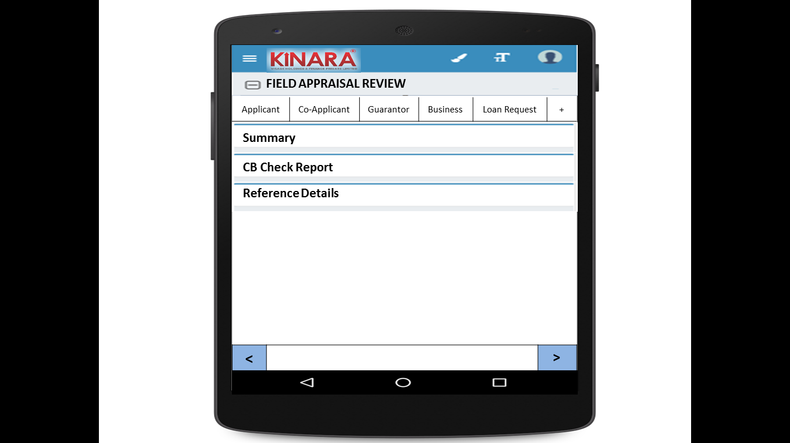

4.2(A) Summary

The initial Summary screen will look as below- with 1 sub-tab

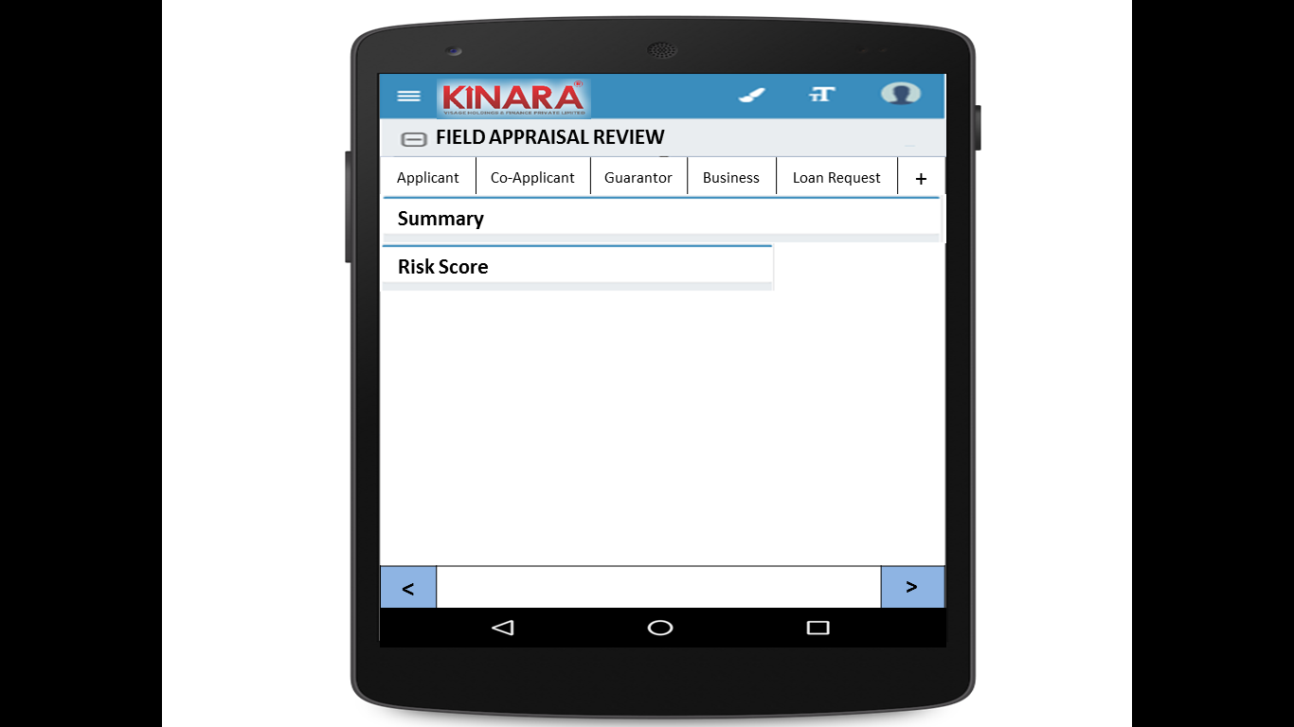

4.2(A1) Risk Score

|  |  |
| --- | --- |
| Page 1 | Page 2 |
| Page 3 | Page 4 |

4.2(B) CB Check Report

CB report for each entity will be displayed under their respective tabs, as below.

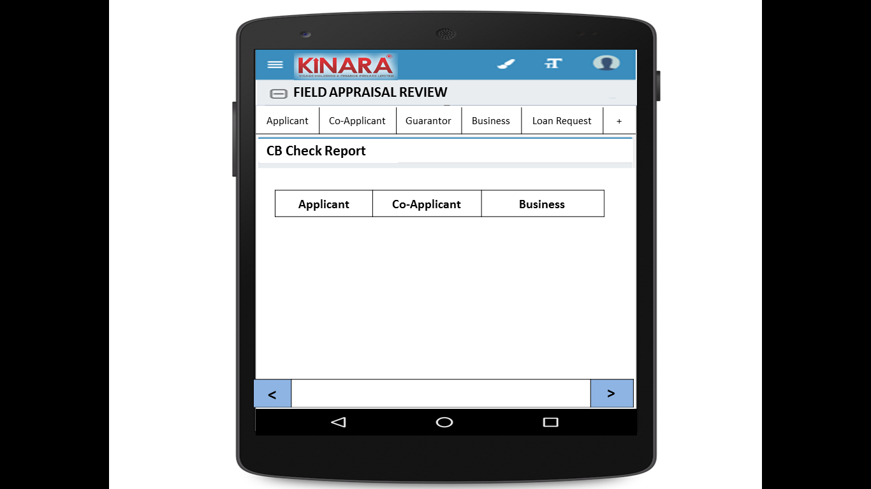

4.2(C) Reference Details

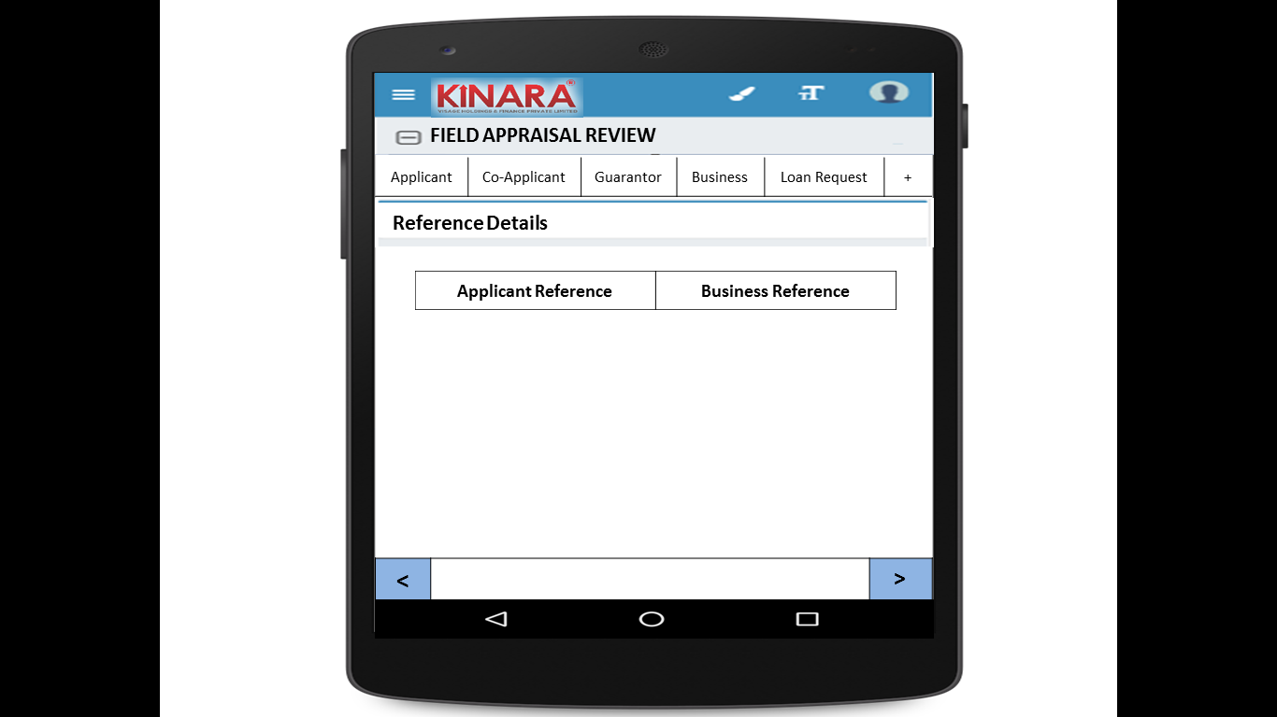

4.2(C1) Reference –sub tabs

|  |  |
| --- | --- |
| Page 1 | Page 2 |

**4.2.1 Applicant**

Entity wise data display will start with Applicant

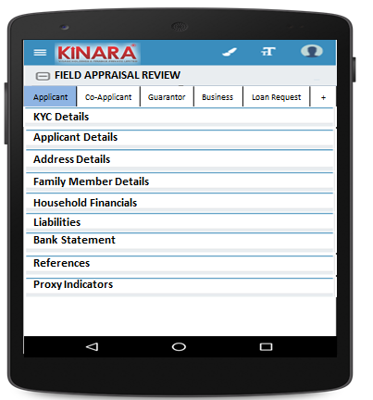

* + - 1. KYC Details:

All details will be auto-populated from field appraisal stage

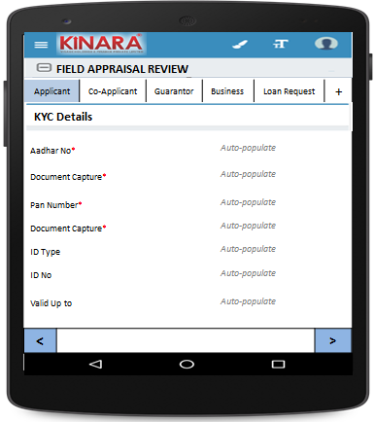

* + - 1. Applicant Details

All details will be auto-populated from field appraisal stage

|  |  |  |
| --- | --- | --- |
| Page 1 | Page 2 | Page 3 |

* + - 1. Address Details

All details will be auto-populated from field appraisal stage

|  |  |
| --- | --- |
| Page 1 | Page 2 |
| Page 3 | Page 4 |

* + - 1. Family Member Details

All details will be auto-populated from field appraisal stage

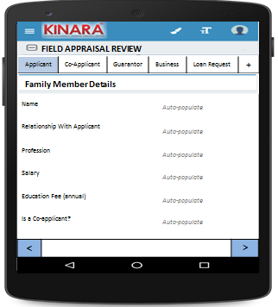

* + - 1. Household Financials

All details will be auto-populated from field appraisal stage

|  |  |
| --- | --- |
| Page 1 | Page 2 |

* + - 1. Liabilities

All details will be auto-populated from field appraisal stage

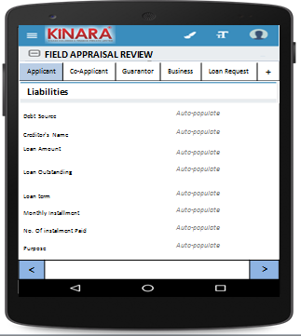

* + - 1. Bank Statement Details

All details will be auto-populated from field appraisal stage

|  |  |
| --- | --- |
| Page 1 | Page 2 |

* + - 1. References

All details will be auto-populated from field appraisal stage

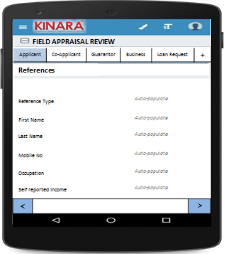

* + - 1. Proxy Indicators

All details will be auto-populated from field appraisal stage

|  |  |
| --- | --- |
| Page 1 | Page 2 |
| Page 3 | Page 4 |

* + 1. **Co-applicant**

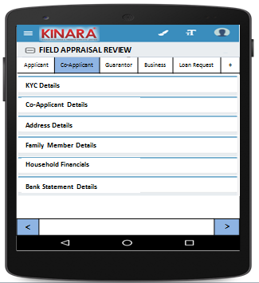

* + - 1. KYC Details

All details will be auto-populated from field appraisal stage

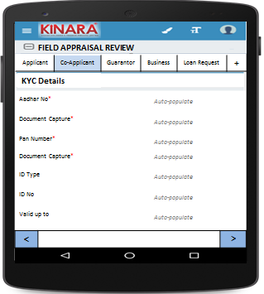

* + - 1. Co-applicant Details

All details will be auto-populated from field appraisal stage

|  |  |  |
| --- | --- | --- |
| Page 1 | Page 2 | Page 3 |

* + - 1. Address Details

All details will be auto-populated from field appraisal stage

|  |  |
| --- | --- |
| Page 1 | Page 2 |
| Page 3 | Page 4 |

* + - 1. Family Member Details

All details will be auto-populated from field appraisal stage

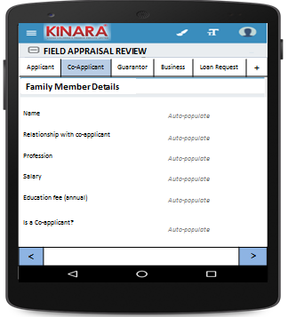

* + - 1. Household Financials  
         All details will be auto-populated from field appraisal stage

|  |  |
| --- | --- |
| Page 1 | Page 2 |

* + - 1. Bank Statement Details

All details will be auto-populated from field appraisal stage

|  |  |
| --- | --- |
| Page 1 | Page 2 |

* + 1. **Guarantor**

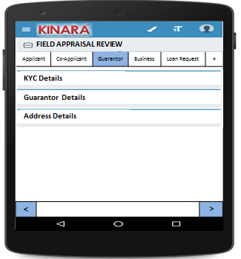

* + - 1. KYC Details

All details will be auto-populated from field appraisal stage

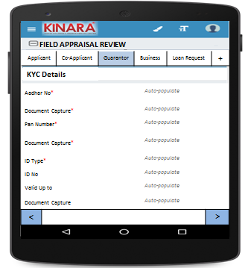

* + - 1. Guarantor Details

All details will be auto-populated from field appraisal stage

|  |  |  |
| --- | --- | --- |
| Page 1 | Page 2 | Page 3 |

* + - 1. Address Details

All details will be auto-populated from field appraisal stage

|  |  |
| --- | --- |
| Page 1 | Page 2 |
| Page 3 | Page 4 |

* + 1. **Business**

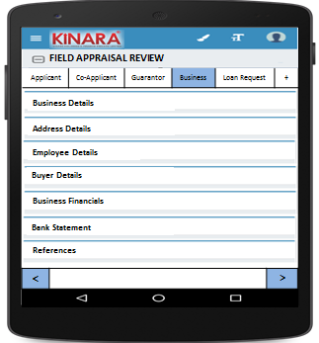

* + - 1. Business Details

All details will be auto-populated from field appraisal stage

|  |  |  |
| --- | --- | --- |
| Page 1 | Page 2 | Page 3 |

* + - 1. Address Details

All details will be auto-populated from field appraisal stage

|  |  |
| --- | --- |
| Page 1 | Page 2 |

* + - 1. Employee Details

All details will be auto-populated from field appraisal stage

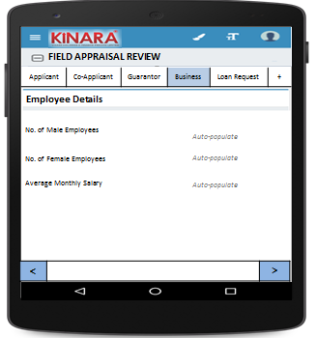

* + - 1. Buyer Details

All details will be auto-populated from field appraisal stage

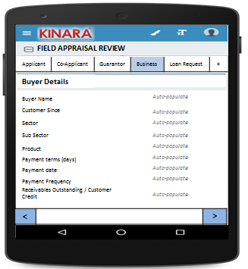

* + - 1. Business Financials

All details will be auto-populated from field appraisal stage

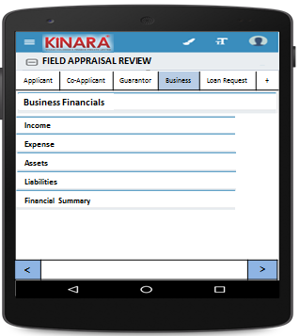

* + - * 1. Income

All details will be auto-populated from field appraisal stage

|  |  |
| --- | --- |
| Page 1 – Through Sales | Page 2 – Other Business Income |

* + - * 1. Expense

All details will be auto-populated from field appraisal stage

|  |  |
| --- | --- |
| Page 1- Raw material expense | Page 2 – Salary and wages |
| Page 3 – Fixed Obligations | Page 4 – Other Expenses |

* + - * 1. Assets

All details will be auto-populated from field appraisal stage

|  |  |
| --- | --- |
| Page 1 – Current Assets | Page 2 – Inventory |
| Page 3 – Machinery (1) | Page 4 – Machinery(2) |
| Page 5 – Other Assets | |

* + - * 1. Liabilities

All details will be auto-populated from field appraisal stage

|  |  |
| --- | --- |
| Page 1 – Fixed | Page 2 – Current |

* + - * 1. Financial Summary

All details will be auto-populated from field appraisal stage

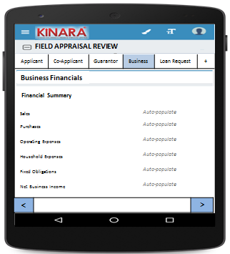

* + - 1. Bank Statement

All details will be auto-populated from field appraisal stage

|  |  |
| --- | --- |
| Page 1 | Page 2 |

* + - 1. References

All details will be auto-populated from field appraisal stage

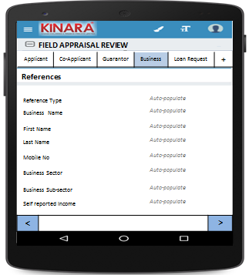

* + 1. **Loan Request**

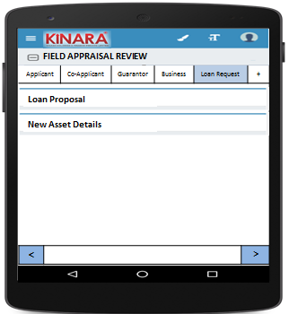

* + - 1. Loan Proposal

All details will be auto-populated from field appraisal stage

|  |  |
| --- | --- |
| Page 1 | Page 2 |

* + - 1. New Asset Details

All details will be auto-populated from field appraisal stage

|  |  |
| --- | --- |
| Page 1 | Page 2 |

* + 1. Remarks  
       All details will be auto-populated from field appraisal stage

|  |  |
| --- | --- |
| Page 1- Click + to view remarks | Page 2 – Remarks entered at different stages can be viewed here with time stamps |

## Functional requirements

* 1. Once the profile is selected from the Field Appraisal Review Queue, the CRO can view all the data captured and scores tabulated up to the field appraisal stage.
  2. CRO will view all data and capture reference remarks
  3. CRO will have four options. Accept/Reject/Hold/Send Back.
  4. In case of any deviations, the CRO can send the loan back to any previous stage, or submit.
  5. On clicking ‘send back’ there should be option to choose which stage to send back to
  6. When submitted, system will calculate Consolidated Risk Score.
  7. Loan application will automatically move to pending for Credit Committee Review queue

## Uploads

-NA-

## Downloads

-NA-

## Reports

-NA-

# Risk Score 2

## UI specification

## Screenshot

## Functional requirements

## Upload

## Download

## Reports